**Experiment 6: Serial Adder**

İbrahim Burak Tanrıkulu 21827852

Şerife Ebru Yardım 21785784

**CODES:**

Full adder: D flip flop:

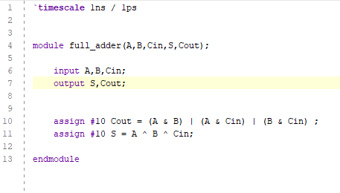 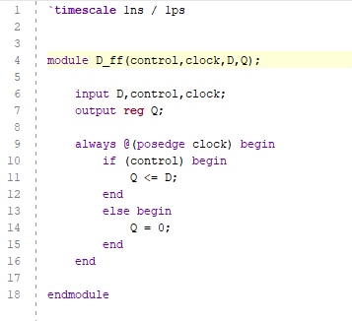

Serial adder: Shift register:

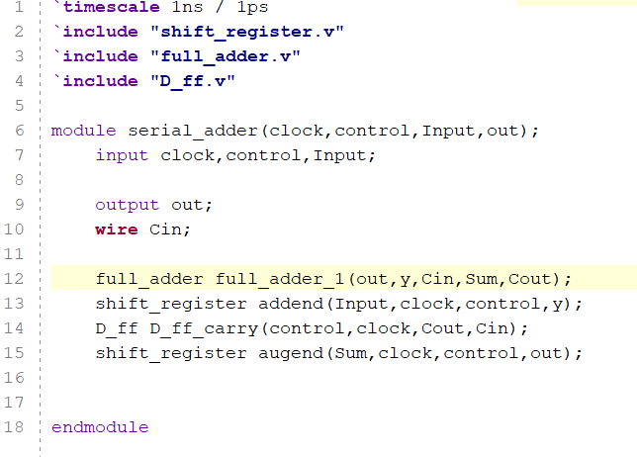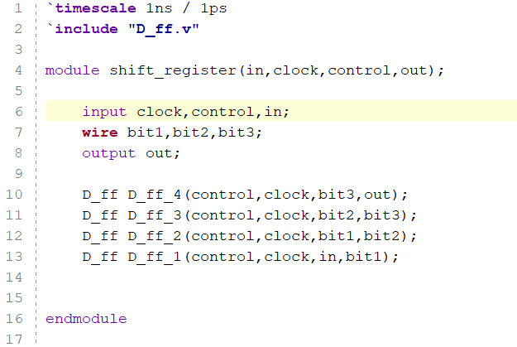

Testbench:

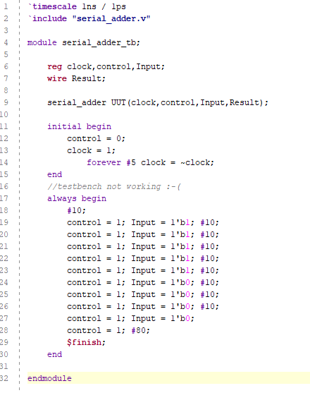

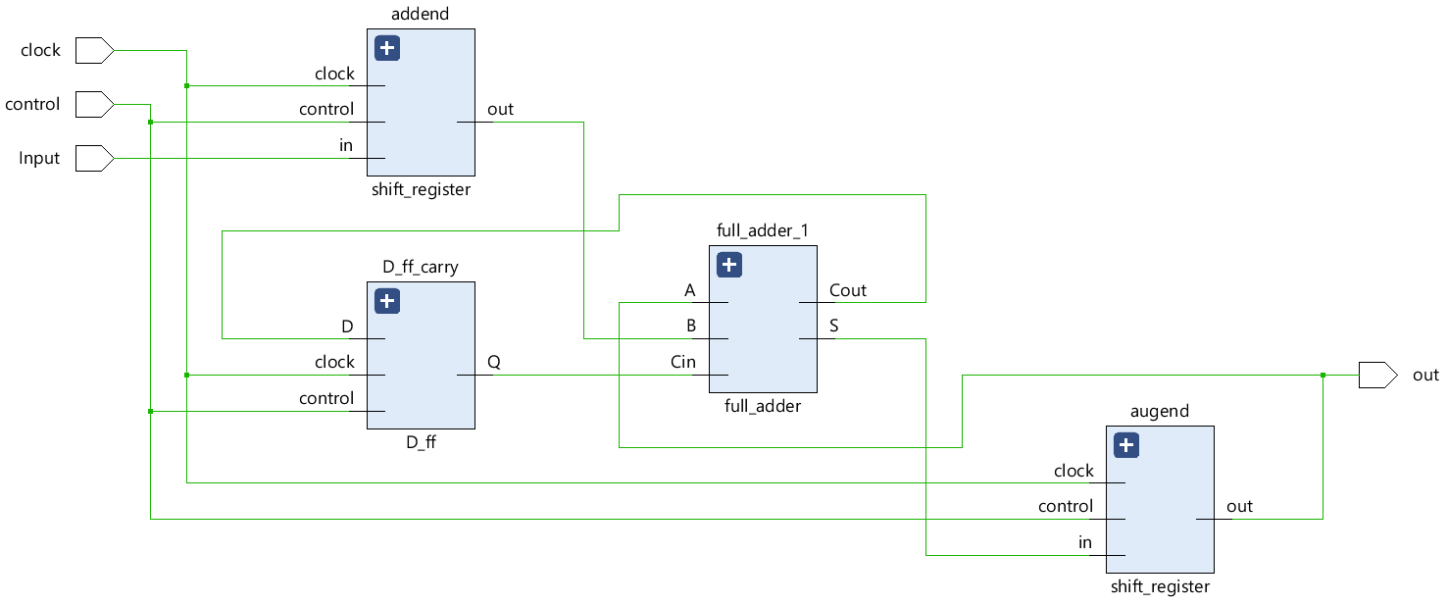

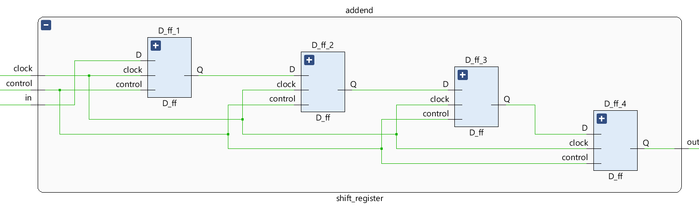

We can read the results after 120 ns. (yellow line in graphics)

0001 + 1110 =

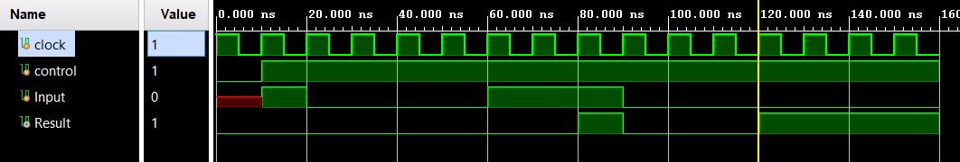

0101 + 0011 =

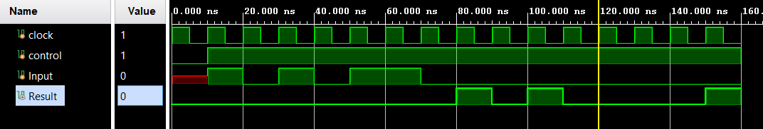

1111 + 0001 =

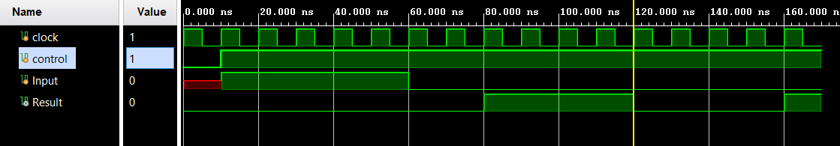

1111 + 1111 =

